LAB 11 HADOOP

## Introduction

In this lab, we installed and configured a single node Hadoop instance capable to executing and retrieving a Map Reduce Job to count the frequency of words in any given file.

**Steps**

Instructions for installation was followed from <https://hadoop.apache.org/docs/r1.2.1/single_node_setup.pdf>

**SCREENSHOTS OF TASKS PERFOMED:**

1. Installation of CYGWIG

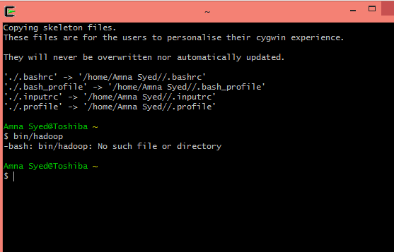

1. Hadoop configuration changes

**Hadoop env.sh**

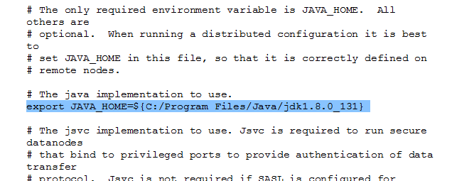

**Coresite.xml**

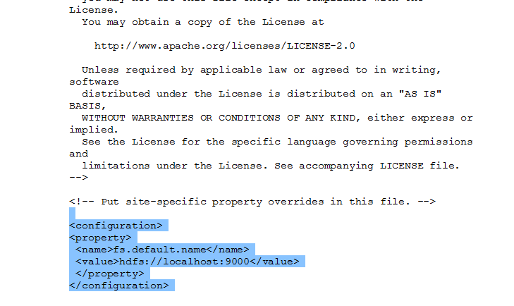

Hdfs.xml

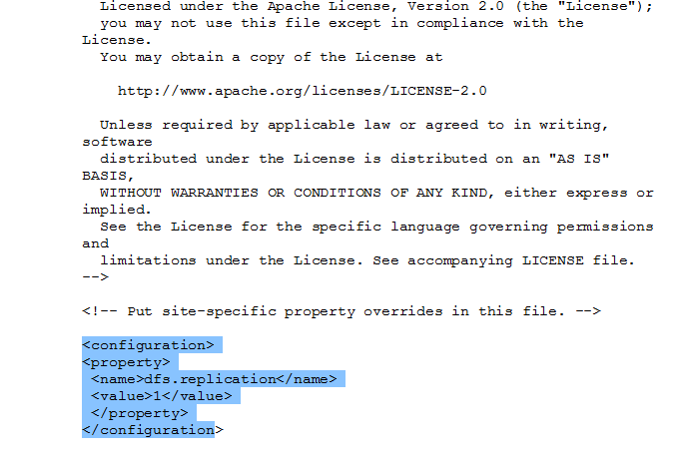

**Mapredsite.xml**

